

DEPARTMENT OF INFORMATION AND COMMUNICATION TECHNOLOGY
PROJECT 1 | SESSION: 2 2024/2025

COURSE CODE: DFT40163 | COURSE NAME: WEB DESIGN TECHNOLOGY
CLO 1: Construct the HTML, CSS, JavaScript and jQuery in developing an interactive web page that can be published on web browser (P4, PLO 3)
TOPIC : 1 - 3
NAME :  1. NUR FAIZAH BINTI DALI  2. DHACYANI A/P MUNIANDY  3. NUR LIYANA BINTI MOHD ROSLAN |  | REGISTRATION NO :  1. 10DDT23F1069  2. 10DDT23F1502  3. 10DDT23F1087
CLASS : DDT4B |  | DURATION : 16 hours

CLO | MARKS
CLO 1P | /50
Total marks | /100

CHARITY & FUNDRAISING WEBSITE PROJECT

INTRODUCTION
This project is a group-based activity where each team will design and develop a Charity & Fundraising Website. The website should be interactive, well-designed, and follow modern web standards (W3C-compliant). In addition, you will deliver an oral presentation on the design and implementation of the website. The project will involve creating a functional Charity & Fundraising Website using HTML and CSS only.

QUESTIONS (CLO1, P4)

1. Construct an Interactive CHARITY & FUNDRAISING WEBSITE using HTML and CSS only.
The website MUST include the following features:

a. The website MUST contain at least 5 sections:
- Home (Introduction to the charity and its mission)
- About Us (History, vision and goals of the organization)
- Campaigns (Showcase active charity campaigns with details)
- Get Involved (Options for volunteering, donations and partnerships)
- Contact Us (Provide ways to reach the organization)

b. The Contact Us page MUST contain a form with the following fields:
- Full Name
- Email Address
- Subject
- Message

c. The website MUST include:
- Relevant images representing charity activities
- Properly structured navigation menus
- Appropriate CSS styling for readability and engagement

2. Storyboard Requirement:
a. Each team is required to create a storyboard for the Charity & Fundraising Website, illustrating the layout and design choices for each page.
b. The storyboard MUST include:
- Visual representation of navigation flow
- Content structure for each section (Home, About Us, Campaigns, Get Involved, Contact Us)
- Design elements such as images, fonts, and colors

ADDITIONAL NOTES:
- Plagiarism Warning:
- You are NOT ALLOWED to use ready-made templates. While you can refer to templates for ideas, you are expected to create the code yourself. Copycatting and plagiarism will result in an F grade for this project.

- Duration:
- This project has a duration of 16 hours. Make sure you manage your time effectively to complete both the storyboard and the HTML/CSS development.

ASSESSMENT CRITERIA:
Your project will be evaluated based on the following criteria:
- Storyboard completeness and accuracy
- HTML structure and organization
- CSS implementation and consistency
- Visual design (fonts, colors, layout)
- Navigation and usability
- Browser compatibility (Google Chrome, Mozilla Firefox)
- Code quality (indentation, comments, structure)

All the Best!

INFORMATION AND COMMUNICATION TECHNOLOGY DEPARTMENT
PROJECT 1 RUBRIC | SESSION: 2 2024/2025

COURSE CODE | DFT40163 |  | COURSE NAME | WEB DESIGN TECHNOLOGY
ASSESSMENT  TASK | PROJECT 1 |  | LECTURER’S NAME | PN. SHU HAILA BINTI MOHD YUSOF
STUDENT’S NAME | 1 | NUR FAIZAH BINTI DALI | REGISTRATION NUMBER | 1 | 10DDT23F1069
 | 2 | DHACYANI A/P MUNIANDY |  | 2 | 10DDT23F1502
 | 3 | NUR LIYANA BINTI MOHD ROSLAN |  | 3 | 10DDT23F1087

Criteria | 4 (Excellent) | 3 (Good) | 2 (Satisfactory) | 1 (Needs Improvement) | STUDENTS’ SCORE
 |  |  |  |  | S1 | S2 | S3 | S4
Storyboard Design | Clear, comprehensive, and well-organized. All sections accurately represented. | Clear and organized but some sections need refinement. | Basic representation with incomplete details in some sections. | Missing major sections or poorly organized.
HTML Structure & Completeness | Fully follows HTML5 structure with proper semantic tags. All sections present. | Mostly follows HTML5 structure with minor omissions. Most sections complete. | Some HTML5 structure errors. Several sections are missing or incomplete. | Lacks HTML5 structure, many sections incomplete or incorrect.
CSS Implementation (Home Page) | Excellent use of CSS with clean, consistent styling for layout, fonts, colors, and responsiveness. | Good CSS styling, minor issues with layout or responsiveness. | Basic CSS styling, inconsistent layout or issues with font/color choices. | Minimal or no CSS applied to the home page, poor styling.
CSS Implementation (About Us Page) | Well-structured and visually appealing design, with appropriate fonts, colors, and images. Layout is fully responsive. | Good design with appropriate colors and fonts, minor alignment issues. | Basic layout with limited styling, some elements appear misaligned or inconsistent. | Poor design, minimal CSS, or default styling with no clear visual hierarchy.
CSS Implementation (Campaigns Page) | Stylish and engaging presentation of campaigns, with clear sections, hover effects, and visual hierarchy. | Good layout with relevant styles but may lack some interactive elements. | Basic formatting applied but lacks attractiveness and consistency in spacing or typography. | Poorly designed, unstructured layout with little to no CSS styling.
CSS Implementation (Get Involved Page) | Engaging layout with well-styled buttons, forms, and sections for volunteering or donations. Fully responsive. | Good styling with effective formatting, but some responsiveness issues. | Basic layout with minimal styling, alignment problems, or unappealing color schemes. | No proper CSS applied, page looks unstructured and unappealing.
CSS Implementation (Contact Us Page) | Professionally styled form with good spacing, alignment, and responsiveness. Clear input fields and labels. | Well-styled form, but minor alignment or spacing issues. | Basic form with minimal styling, lacks proper spacing or clear labels. | Poorly formatted or no CSS applied, form appears unstructured.
Navigation Structure | Clear, intuitive and fully functional navigation across all sections. | Navigation is mostly clear, minor issues with functionality. | Navigation is functional but confusing in parts. | Poor navigation, difficult to use or non-functional links.
Responsiveness & Compatibility | Fully responsive and displays perfectly in Chrome and Firefox. | Responsive with minor display issues in Chrome or Firefox. | Some responsiveness issues, noticeable display problems in either browser. | Major responsiveness issues, significant display problems in multiple browsers.
Code Quality & Organization | Clean, well-organized code with proper indentation and comments. | Mostly organized code with minor indentation issues. Some comments. | Code is present but lacks organization and proper comments. | Disorganized code, missing comments, improper indentation.
Use of Media (Images/Video) | Media integrated effectively with appropriate sizes and formats across all pages. | Media is mostly well-integrated but there are some inconsistencies in size or format. | Basic use of media, issues with size or formats. | Poor or no use of media, incorrect formatting.
Report/ Documentation | Detailed, well-structured report that explains design choices and implementation. | Good report with minor omissions in explaining design and implementation. | Basic report with incomplete explanations. | Poor or no report, lacking details of design and implementation.
Timely Submission |  |  | Submitted on time with all project components completed. | Submitted slightly late with all project components.
TOTAL SCORE (/50)

Note:
If any required section or task as outlined in the project is missing or incomplete, a score of ZERO will be awarded for that specific section, regardless of the rubrics' criteria. Ensure all sections are fully completed to qualify for grading.

ANSWER

STORYBOARD FOR EACH PAGES

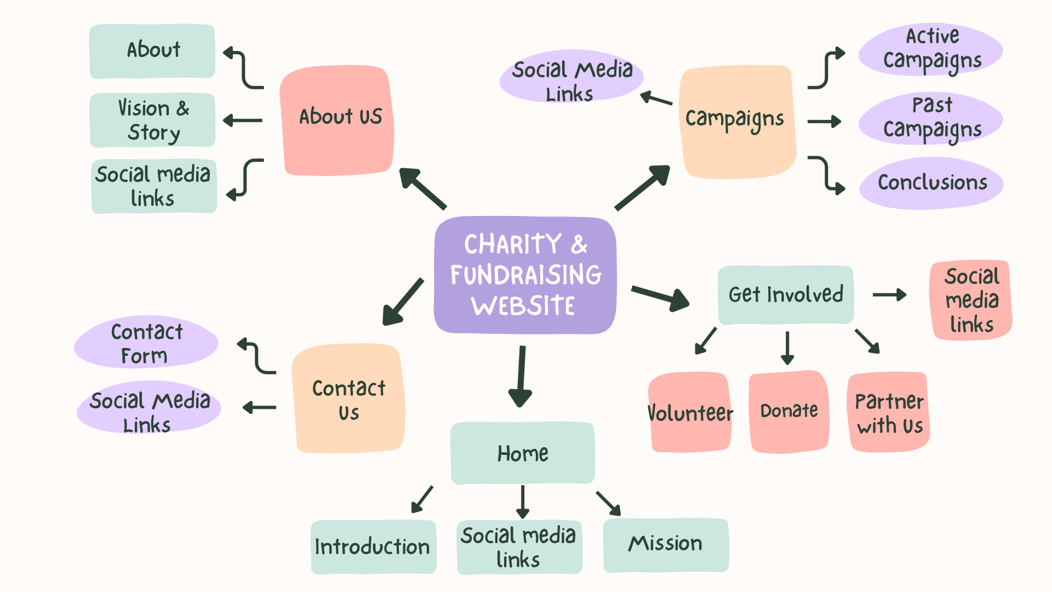
Screen # | 1 | Topic | Home |  |  | Screen
Screen objective | Introduction for Charity and Fundraising website |  |  |  |  | 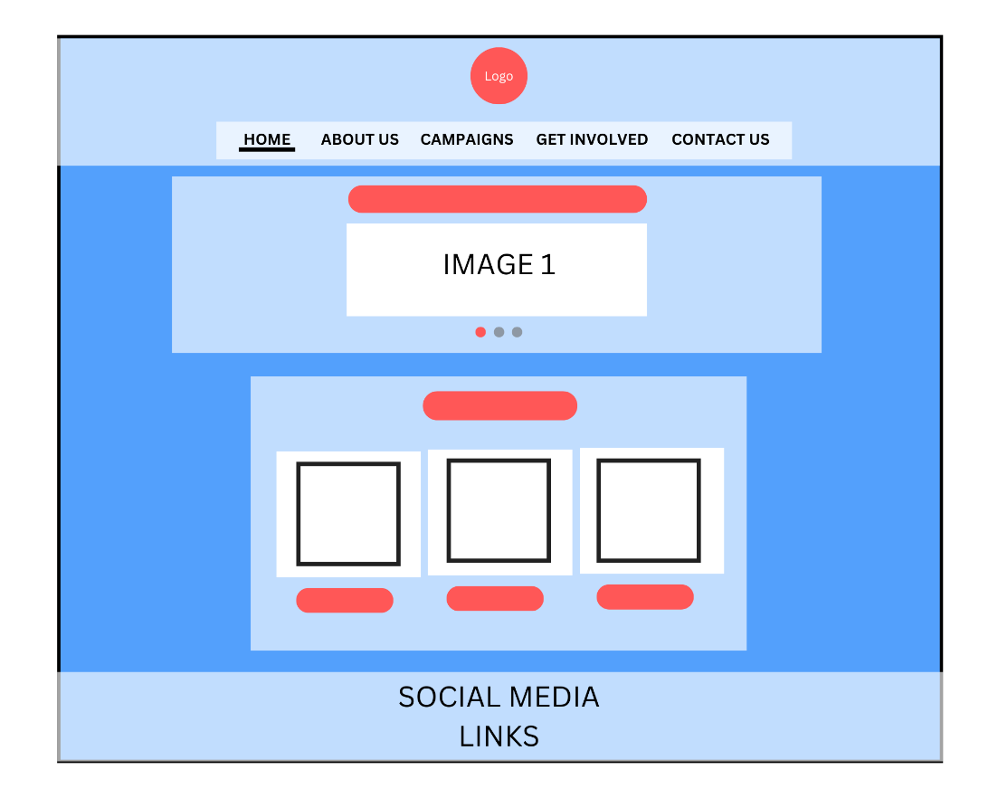
Screen before | None | Screen after |  | 2
Learning content | Introduction for Charity and Fundraising website
Instructions | Navigation:  - Navigation bar that contains Home, About Us, Campaigns, Get Involved and Contact Us  - Social media links
Audio script | None
Media | logo.png  charity1.png  charity2.png  charity3.png  food.png  Education1.png  Healthcare.png

Screen # | 2 | Topic | About Us |  |  | Screen
Screen objective | Introduction for About Us |  |  |  |  | 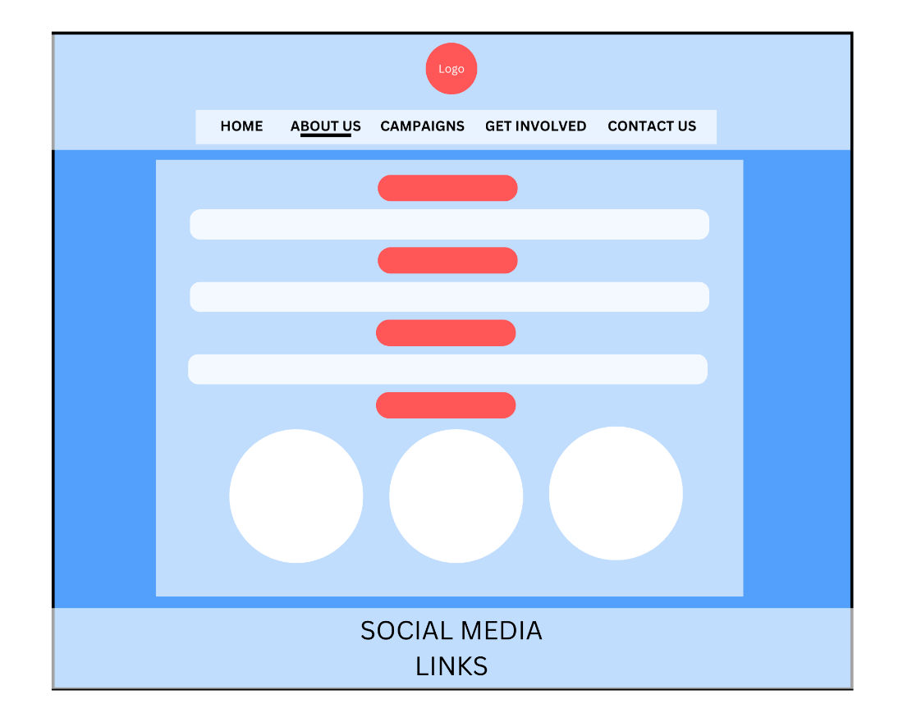
Screen before | 1 | Screen after |  | 3
Learning content | Explanation about history, vision and story including team members intoduction.
Instructions | Navigation:  - Navigation bar that contains Home, About Us, Campaigns, Get Involved and Contact Us  - Social media links
Audio script | None
Media | logo.png  person1.jpeg  person2.png  person3.jpg

Screen # | 3 | Topic | Campaigns |  |  | Screen
Screen objective | Introduction for Campaigns |  |  |  |  | 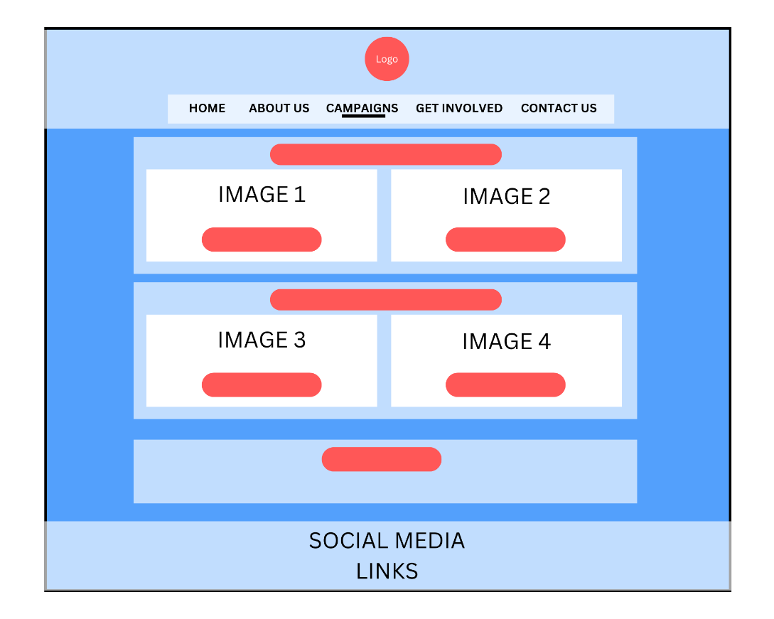
Screen before | 2 | Screen after |  | 4
Learning content | To show active charity campaigns with details
Instructions | Navigation:  - Navigation bar that contains Home, About Us, Campaigns, Get Involved and Contact Us  - Learn more button for further information  - Social media links
Audio script | None
Media | logo.png  provide_water.jpg  education.png  provide_food.jpg  medical_aid.jpg

Screen # | 4 |  | Topic |  | Get Involved |  |  |  |  |  | Screen
Screen objective | Introduction for Get Involved |  |  |  |  |  |  |  |  |  | 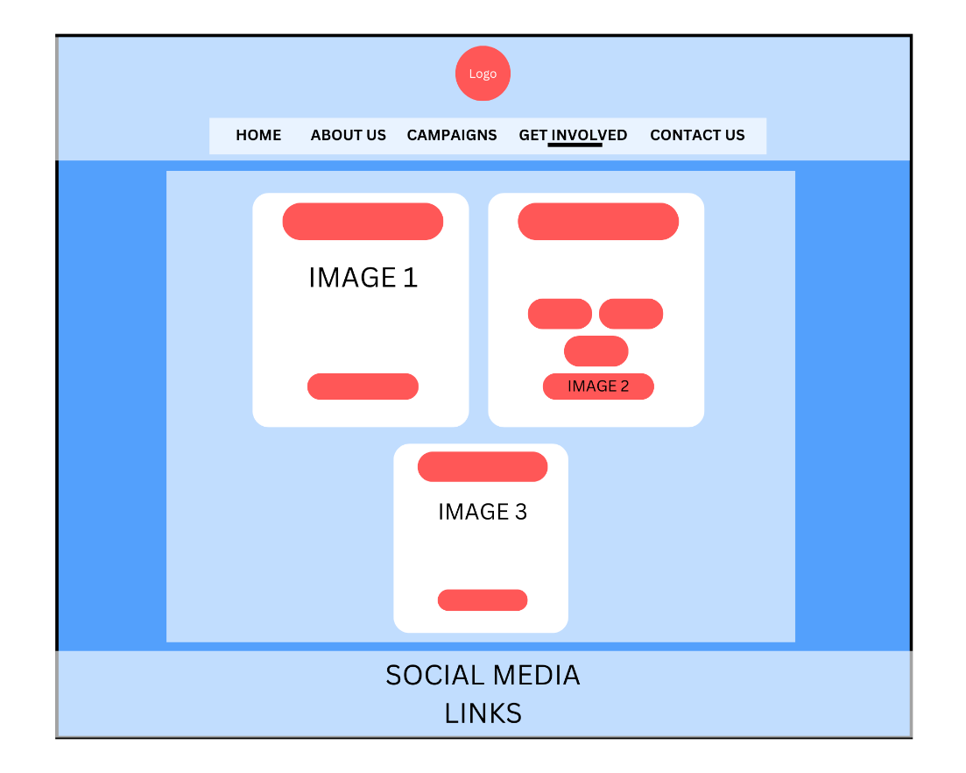
Screen before | 3 |  | Screen after |  |  |  | 5
Learning content | To show options for volunteering, donations and partnerships
Instructions | Navigation:  - Navigation bar that contains Home, About Us, Cmapigns, Get Involved and Contact Us  - Social media links  Button:  - Learn more buttons for further information
Audio script | None
Media | logo.png  volunteer.jpg  donate.png  partner-with-us.png
Screen # | 5 | Topic |  | Contact Us |  |  |  |  |  | Screen
Screen objective | Introduction for Contact Us |  |  |  |  |  |  |  |  | 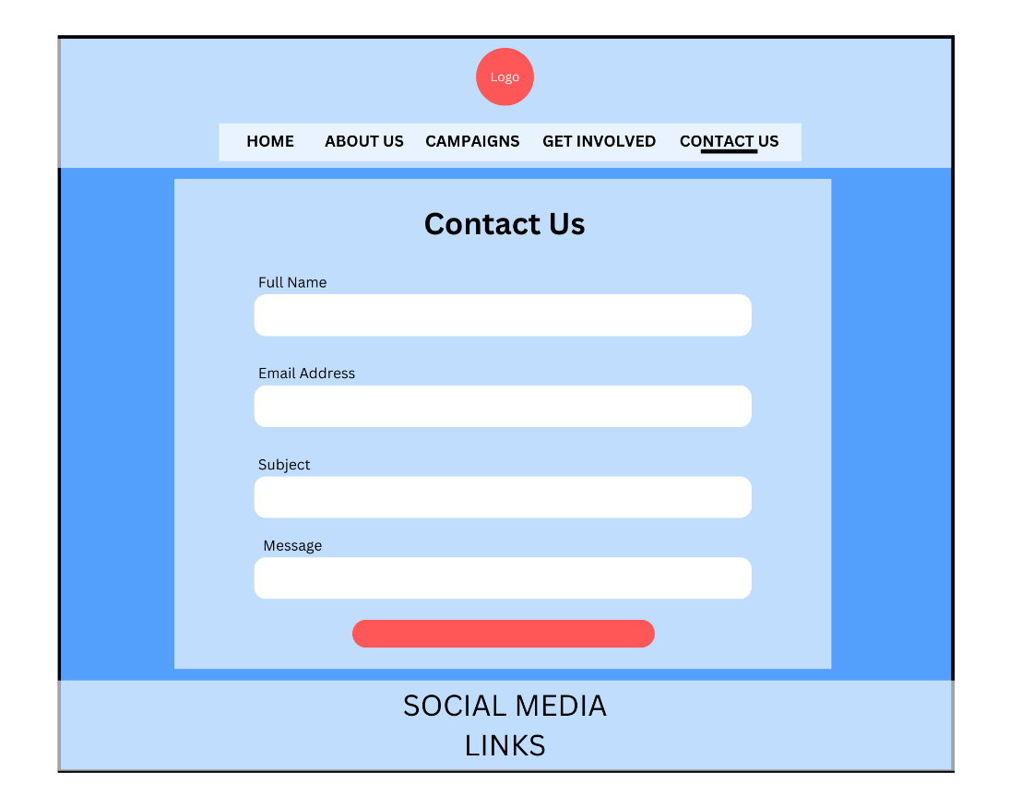
Screen before | 4 | Screen after |  |  |  | None
Learning content | To provide ways to reach the organization
Instructions | Navigation:  - Navigation bar that contains Home, About Us, Cmapigns, Get Involved and Contact Us  - Social media links  Button:  - Submit button for the contact us form
Audio script | None
Media | Logo.png

CODING FOR EACH HTML FILES
File name: home.html
Copy & paste the coding here.
Font-type=Consolas; font-size=10. Line-spacing=single (1.0)

<!DOCTYPE html>
<head>
<title>Home</title>
<link rel="stylesheet" href="styles.css"> <!-- Link to external CSS file for styling -->
</head>
<body>
<header>
<img src="images/logo.png" alt="Charity Logo" class="logo"> <!-- Logo of the charity -->
<nav>
<ul>
<!-- Navigation menu to move between pages -->
<li><a href="home.html" class="active">HOME</a></li>
<li><a href="about.html">ABOUT US</a></li>
<li><a href="campaigns.html">CAMPAIGNS</a></li>
<li><a href="get-involved.html">GET INVOLVED</a></li>
<li><a href="contact.html">CONTACT US</a></li>
</ul>
</nav>
</header>

<section id="home">
<h2>Changing Lives, One Act of Kindness at a Time</h2>
<p><b>"Join us in making a difference by supporting our charity initiatives. Your small effort can create a big impact!"</b></p>

<div class="slideshow-container"> <!-- Container for the image slideshow -->
<!-- Radio buttons to control the slides -->
<input type="radio" name="slider" id="slide1" checked>
<input type="radio" name="slider" id="slide2">
<input type="radio" name="slider" id="slide3">

<div class="slides"> <!-- Wrapper for the slideshow images -->
<div class="slide">
<img src="images/charity1.png" alt="Helping Hands">
<p>Uplift communities and bring hope to those in need.</p>
</div>
<div class="slide">
<img src="images/charity2.png" alt="Food Donation">
<p>Building a brighter future for everyone.</p>
</div>
<div class="slide">
<img src="images/charity3.png" alt="Community Support">
<p>A small act of kindness can fill an empty plate.</p>
</div>
</div>

<div class="navigation">
<label for="slide1" class="dot"></label>
<label for="slide2" class="dot"></label>
<label for="slide3" class="dot"></label>
</div>
</div>
</section>

<section id="mission"> <!-- Section for displaying the organization's mission -->
<h2>Our Mission</h2>
<p><b>We aim to support underprivileged communities by providing food, education, and healthcare.</b></p>

<div class="our-mission">
<div class="option">
<div class="option-box">
<img src="images/food.png" alt="Food" class="option-img">
</div>
</div>
<div class="option">
<div class="option-box">
<img src="images/Education1.png" alt="Education" class="option-img">
</div>
</div>
<div class="option">
<div class="option-box">
<img src="images/Healthcare.png" alt="Healthcare" class="option-img">
</div>
</div>
</div>
</section>

<footer>
<!-- Footer with contact info and social media links -->
<h3>Email: info@echarity.com</h3>
<h3>Phone: +123-456-7890</h3>
<p>Follow us on:</p>
<a href="#">Facebook</a> | <a href="#">Twitter</a> | <a href="#">Instagram</a>
<h4>&copy; 2023 E-Charity. All rights reserved.</h4>
<h4>Powered by E-Charity Network.</h4>
</footer>
</body>
</html>

File name: about.html
Copy & paste the coding here.
Font-type=Consolas; font-size=10. Line-spacing=single (1.0)

<!DOCTYPE html>
<head>
<title>About Us</title>
<link rel="stylesheet" href="styles.css"> <!-- Linking external CSS for styling -->
</head>
<body>
<header>
<img src="images/logo.png" alt="Charity Logo" class="logo"> <!-- Logo for branding -->
<nav>
<ul>
<!-- Navigation links for different sections -->
<li><a href="home.html">HOME</a></li>
<li><a href="about.html" class="active">ABOUT US</a></li>
<li><a href="campaigns.html">CAMPAIGNS</a></li>
<li><a href="get-involved.html">GET INVOLVED</a></li>
<li><a href="contact.html">CONTACT US</a></li>
</ul>
</nav>
</header>

<section id="about">
<h2>About Us</h2>
<p>Our charity organization is dedicated to making the world a better place by helping those in need. We work with local communities to provide essential resources and support.</p>

<h2>Our Vision</h2>
<p>"To create a world where kindness, generosity, and support ensure that no one is left behind in the pursuit of a better life."</p>

<h3>Our Story</h3>
<p>Founded in 2025, we have been committed to supporting various causes, including education, food, and healthcare. Our volunteers and donors play a crucial role in achieving our mission.</p>

<h3>Our Team</h3>
<div class="team">
<!-- Team members section with images and names -->
<div class="member">
<img src="images/person1.jpeg" alt="Founder">
<p><strong>NUR FAIZAH</strong><br>Founder & CEO</p>
</div>
<div class="member">
<img src="images/person2.png" alt="Co-Founder">
<p><strong>DHACYANI</strong><br>Co-Founder</p>
</div>
<div class="member">
<img src="images/person3.jpg" alt="Manager">
<p><strong>NUR LIYANA</strong><br>Project Manager</p>
</div>
</div>
</section>

<footer>
<!-- Footer section with contact details and social media links -->
<h3>Email: info@echarity.com</h3>
<h3>Phone: +123-456-7890</h3>
<p>Follow us on:</p>
<a href="#">Facebook</a> | <a href="#">Twitter</a> | <a href="#">Instagram</a>
<h4>&copy; 2023 E-Charity. All rights reserved.</h4>
<h4>Powered by E-Charity Network.</h4>
</footer>
</body>
</html>

File name: campaigns.html
Copy & paste the coding here.
Font-type=Consolas; font-size=10. Line-spacing=single (1.0)

<!DOCTYPE html>
<head>
<title>Contact Us</title>
<link rel="stylesheet" href="styles.css"> <!-- Link to external CSS file for styling -->
</head>
<body>
<header>
<img src="images/logo.png" alt="Charity Logo" class="logo"> <!-- Logo of the charity -->
<nav>
<ul>
<!-- Navigation menu for different pages -->
<li><a href="home.html">HOME</a></li>
<li><a href="about.html">ABOUT US</a></li>
<li><a href="campaigns.html">CAMPAIGNS</a></li>
<li><a href="get-involved.html">GET INVOLVED</a></li>
<li><a href="contact.html" class="active">CONTACT US</a></li> <!-- Highlights active page -->
</ul>
</nav>
</header>

<!-- Contact section where users can reach out -->
<section id="contact">
<h1>Contact Us</h1>
<form method="post">
<!-- Input field for full name -->
<label for="full-name">Full Name</label>
<input type="text" id="full-name" name="full-name" required>

<!-- Input field for email address -->
<label for="email-address">Email Address</label>
<input type="text" id="email-address" name="email-address" required>

<!-- Input field for subject -->
<label for="subject">Subject</label>
<input type="text" id="subject" name="subject" required>

<!-- Text area for the user's message -->
<label for="message">Message</label>
<textarea id="message" name="message" required></textarea>

<!-- Submit button to send the form -->
<input type="submit" value="SUBMIT">
</form>
</section>

<footer>
<!-- Footer with contact info and social media links -->
<h3>Email: info@echarity.com</h3>
<h3>Phone: +123-456-7890</h3>
<p>Follow us on:</p>
<a href="#">Facebook</a> | <a href="#">Twitter</a> | <a href="#">Instagram</a>
<h4>&copy; 2023 E-Charity. All rights reserved.</h4>
<h4>Powered by E-Charity Network.</h4>
</footer>
</body>
</html>

File name: get-involved.html
Copy & paste the coding here.
Font-type=Consolas; font-size=10. Line-spacing=single (1.0)

<!DOCTYPE html>
<head>
<title>About Us</title>
<link rel="stylesheet" href="styles.css"> <!-- Link to external stylesheet -->
</head>
<body>
<header>
<img src="images/logo.png" alt="E-Charity Logo" class="logo"> <!-- Charity logo -->
<nav>
<ul>
<!-- Navigation menu for different pages -->
<li><a href="home.html">HOME</a></li>
<li><a href="about.html">ABOUT US</a></li>
<li><a href="campaigns.html">CAMPAIGNS</a></li>
<li><a href="get-involved.html" class="active">GET INVOLVED</a></li> <!-- Highlights active page -->
<li><a href="contact.html">CONTACT US</a></li>
</ul>
</nav>
</header>

<main>
<!-- Section for ways to get involved -->
<section class="features">

<!-- Volunteer section -->
<div class="feature">
<h2>BECOME A VOLUNTEER</h2>
<img src="images/volunteer1.jpg" alt="Volunteer1"> <!-- Image of volunteer work -->
<p>Join the charity as a volunteer to contribute your time and skills.</p>
<p>Help in organizing events, campaigns, and other activities.</p>
<a href="#" class="btn">Join us Now</a> <!-- Call-to-action button -->
</div>

<!-- Donation section -->
<div class="feature">
<h2>DONATE</h2>
<p>Your contributions help us make a difference in the lives of those in need.</p>
<!-- Different donation amount buttons -->
<button class="btn">RM 10</button>
<button class="btn">RM 50</button>
<button class="btn">RM 100</button>
<button class="btn">Donate Now</button> <!-- Fixed missing closing tag -->
<img src="images/donate.png" alt="Donate"> <!-- Image for donation -->
</div>

<!-- Partnership section -->
<div class="feature">
<h2>PARTNER WITH US</h2>
<img src="images/partner-with-us.png" alt="Partner with us"> <!-- Image for partnership -->
<textarea id="message" name="message" required></textarea> <!-- Textbox for partnership message -->
<a href="#" class="btn">Submit</a> <!-- Submission button -->
</div>

</section>
</main>

<footer>
<!-- Footer with contact info and social media links -->
<h3>Email: info@echarity.com</h3>
<h3>Phone: +123-456-7890</h3>
<p>Follow us on:</p>
<a href="#">Facebook</a> | <a href="#">Twitter</a> | <a href="#">Instagram</a>
<h4>&copy; 2023 E-Charity. All rights reserved.</h4>
<h4>Powered by E-Charity Network.</h4>
</footer>
</body>
</html>

File name: contact.html
Copy & paste the coding here.
Font-type=Consolas; font-size=10. Line-spacing=single (1.0)

<!DOCTYPE html>
<head>
<title>Contact Us</title>
<link rel="stylesheet" href="styles.css"> <!-- Link to external CSS file for styling -->
</head>
<body>
<header>
<img src="images/logo.png" alt="Charity Logo" class="logo"> <!-- Logo of the charity -->
<nav>
<ul>
<!-- Navigation menu for different pages -->
<li><a href="home.html">HOME</a></li>
<li><a href="about.html">ABOUT US</a></li>
<li><a href="campaigns.html">CAMPAIGNS</a></li>
<li><a href="get-involved.html">GET INVOLVED</a></li>
<li><a href="contact.html" class="active">CONTACT US</a></li> <!-- Highlights active page -->
</ul>
</nav>
</header>

<!-- Contact section where users can reach out -->
<section id="contact">
<h1>Contact Us</h1>
<form method="post">
<!-- Input field for full name -->
<label for="full-name">Full Name</label>
<input type="text" id="full-name" name="full-name" required>

<!-- Input field for email address -->
<label for="email-address">Email Address</label>
<input type="text" id="email-address" name="email-address" required>

<!-- Input field for subject -->
<label for="subject">Subject</label>
<input type="text" id="subject" name="subject" required> <!-- Fixed input type (was incorrect) -->

<!-- Text area for the user's message -->
<label for="message">Message</label>
<textarea id="message" name="message" required></textarea>

<!-- Submit button to send the form -->
<input type="submit" value="SUBMIT">
</form>
</section>

<footer>
<!-- Footer with contact info and social media links -->
<h3>Email: info@echarity.com</h3>
<h3>Phone: +123-456-7890</h3>
<p>Follow us on:</p>
<a href="#">Facebook</a> | <a href="#">Twitter</a> | <a href="#">Instagram</a>
<h4>&copy; 2023 E-Charity. All rights reserved.</h4>
<h4>Powered by E-Charity Network.</h4>
</footer>
</body>
</html>

CODING FOR CSS FILES
File name: styles.css
Copy & paste the coding here.
Font-type=Consolas; font-size=10. Line-spacing=single (1.0)

/*home.html*/
/* home.html */
/* about.html */

body {
color: black; /* Sets default text color */
text-align: center; /* Centers text for the entire page */
background: url("images/bg.jpg") center/cover fixed no-repeat; /* Sets background image with fixed positioning */
margin: 0;
padding: 0;
font-family: Arial, sans-serif; /* Defines default font */
}

header {
background-color: rgba(255, 255, 255, 0.6); /* Semi-transparent white background */
padding: 10px;
border-bottom: 2px solid #ff5757; /* Adds a red border at the bottom */
}

.logo {
width: 250px; /* Sets logo size */
display: block;
margin: 1px auto; /* Centers logo */
}

nav {
border: 2px solid white;
border-radius: 10px; /* Rounds the edges */
padding: 5px 20px;
background-color: rgba(255, 255, 255, 0.7); /* Semi-transparent white background */
display: inline-block;
margin: 10px auto;
}

nav ul {
list-style: none;
padding: 0;
margin: 0;
display: flex;
justify-content: center; /* Aligns navigation links to the center */
}

nav ul li {
display: inline;
padding: 10px 15px;
}

nav ul li a {
color: black;
text-decoration: none;
font-weight: bold;
padding: 8px 15px;
border-radius: 5px;
}

nav ul li a:hover {
background-color: #ff5757; /* Changes background color on hover */
color: white;
}

nav ul li a.active {
text-decoration: none;
border-bottom: 3px solid black; /* Highlights active link */
padding-bottom: 5px;
}

section {
border: 2px solid rgba(255, 255, 255, 0.6);
padding: 20px;
border-radius: 10px;
margin: 20px auto;
background-color: rgba(255, 255, 255, 0.5); /* Adds a semi-transparent background */
width: 80%;
max-width: 900px;
}

h2, h3 {
background-color: #ff5757;
display: inline-block;
padding: 7px 20px;
border-radius: 5px;
color: white;
}

#home {
width: 100%;
max-width: 1000px;
}

#home img {
width: 100%;
max-width: 800px;
height: auto;
display: block;
}

.team {
display: flex;
justify-content: center;
gap: 20px;
margin-top: 20px;
}

.member {
text-align: center;
}

.member img {
width: 150px;
height: 150px;
object-fit: cover;
border-radius: 50%; /* Makes images circular */
}

footer {
border-top: 2px solid #ff5757;
padding: 10px;
background-color: rgba(255, 255, 255, 0.6);
margin-top: 20px;
text-align: center;
}

footer p {
font-size: 24px;
margin-bottom: 3px;
}

footer a {
font-size: 24px;
font-weight: bold;
text-decoration: none;
color: #ff5757;
}

footer a:hover {
text-decoration: underline;
}

/* Slideshow styling */
.slides {
display: flex;
flex-direction: column;
align-items: center;
}

.slide {
display: none;
}

.slide img {
width: 100%;
max-width: 300px;
border-radius: 10px;
}

/* Radio buttons control slideshow visibility */
#slide1:checked ~ .slides .slide:nth-child(1),
#slide2:checked ~ .slides .slide:nth-child(2),
#slide3:checked ~ .slides .slide:nth-child(3) {
display: block;
}

/* Navigation dots for slideshow */
.navigation {
display: flex;
justify-content: center;
margin-top: 10px;
}

.dot {
width: 15px;
height: 15px;
margin: 5px;
background-color: #ccc;
border-radius: 50%;
cursor: pointer;
display: inline-block;
}

#slide1:checked ~ .navigation label:nth-child(1),
#slide2:checked ~ .navigation label:nth-child(2),
#slide3:checked ~ .navigation label:nth-child(3) {
background-color: #ff5757;
}

input[type="radio"] {
display: none; /* Hides radio buttons */
}

.our-mission {
display: flex;
justify-content: center;
gap: 20px;
flex-wrap: wrap;
}

.option {
text-align: center;
max-width: 250px;
flex: 1;
}

/* About section */
#about p {
border: 2px solid #ff5757;
border-radius: 10px;
padding: 10px 20px;
background-color: rgba(255, 255, 255, 0.7);
display: block;
width: fit-content;
margin: 10px auto;
text-align: center;
}

/* get-involved.html */
/* contact.html */
#contact {
text-align: center;
padding: 20px;
}

#contact form {
max-width: 600px;
margin: 0 auto;
}

#contact label {
display: block;
margin-bottom: 10px;
text-align: left;
}

#contact input, #contact textarea {
width: 100%;
padding: 10px;
margin-bottom: 20px;
border: 1px solid #ccc;
border-radius: 5px;
}

#contact input[type="submit"] {
background-color: #ff5757;
color: white;
border: none;
cursor: pointer;
padding: 10px 20px;
}

/* Features section */
.features {
display: flex;
flex-wrap: wrap;
justify-content: center;
padding: 20px 0;
}

.feature, .option {
background: white;
border: 1px solid #ddd;
border-radius: 10px;
padding: 20px;
margin: 10px;
width: calc(33.333% - 40px);
box-shadow: 0 2px 4px rgba(0, 0, 0, 0.1);
text-align: center;
}

.feature img, .option img {
max-width: 100px;
margin-bottom: 10px;
}

/* Button styling */
.feature .btn {
display: inline-block;
padding: 10px;
background-color: #ffffff;
color: #ff5757;
text-decoration: none;
border: 2px solid #ff5757;
border-radius: 5px;
font-weight: bold;
margin-top: 10px;
}

.feature .btn:hover {
color: #ffffff;
background-color: #ff5757;
border: 2px solid #ca4e4e;
cursor: pointer;
}

/* campaigns.html */
#campaigns {
text-align: center;
padding: 20px;
}

.campaigns-container {
display: flex;
flex-wrap: wrap;
justify-content: center;
gap: 20px;
padding: 20px;
}

.campaign {
background-color: rgba(255, 255, 255, 0.7);
border: 2px solid #ff5757;
border-radius: 10px;
padding: 15px;
max-width: 300px;
text-align: center;
box-shadow: 2px 2px 10px rgba(0, 0, 0, 0.1);
}

.campaign img {
width: 100%;
max-width: 250px;
height: auto;
border-radius: 10px;
}

.campaign h3 {
background-color: #ff5757;
display: inline-block;
padding: 7px 15px;
border-radius: 5px;
color: white;
margin: 10px 0;
}

SCREENSHOT OF OUTPUT (DESKTOP INTERFACE)
Copy & paste the screenshot with the file name.

home.html
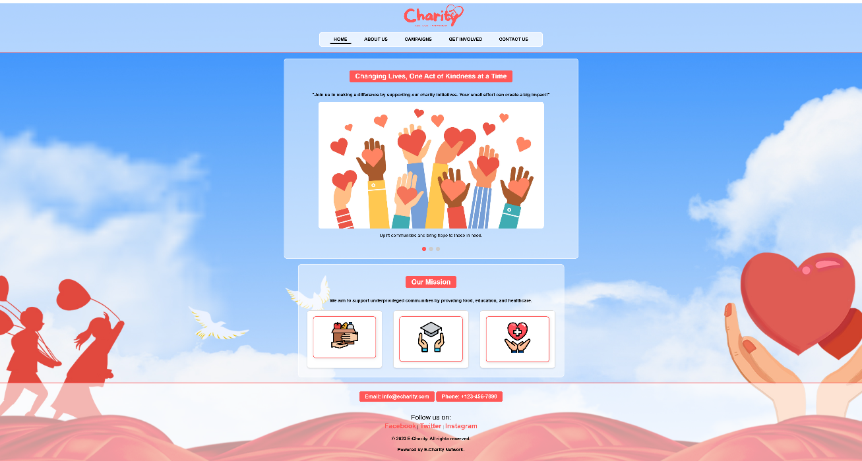
about.html
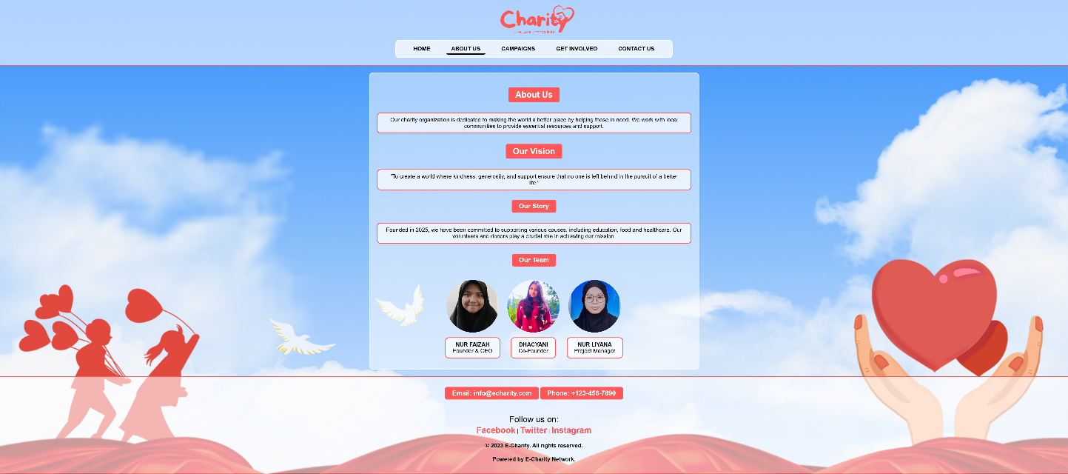

campaigns.html
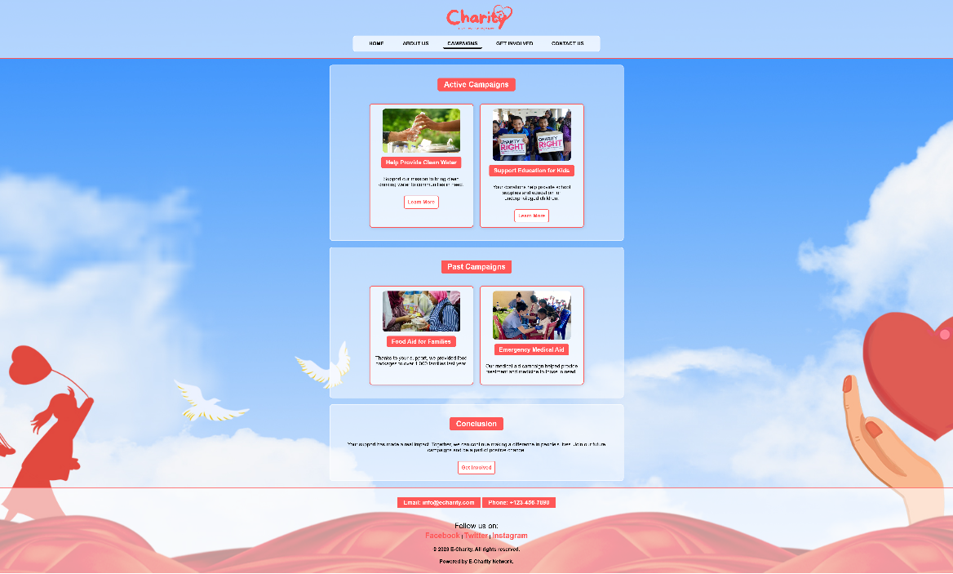
get-involved.html
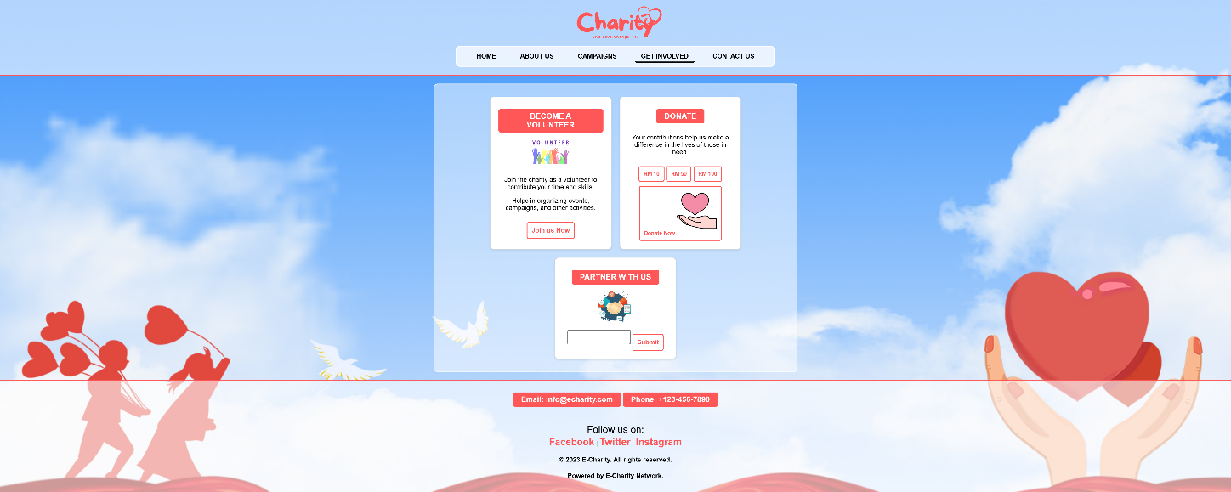

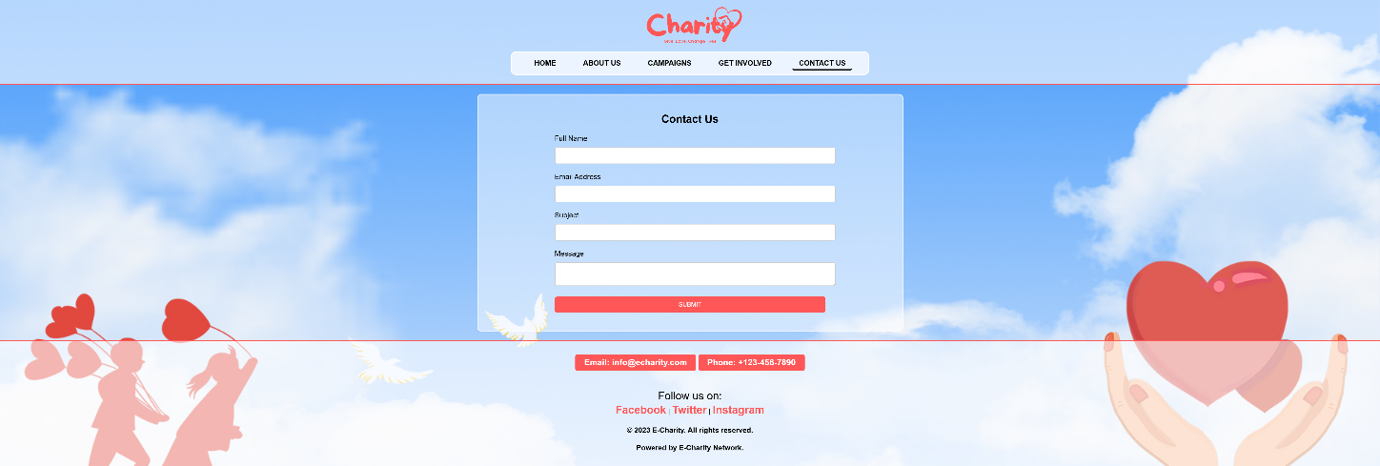
contact.html

